**BIOINFORMATICS ASSIGNMENT 1 (Day 1 - 5)**

***Note: You will be added in a slack community of Bversity for further doubts and communications***

1. Gene Name: Tumor Protein p53 Gene

2. Function of the Gene: This gene encodes a tumor suppressor protein containing transcriptional activation, DNA binding, and oligomerization domains. The encoded protein responds to diverse cellular stresses to regulate expression of target genes, thereby inducing cell cycle arrest, apoptosis, senescence, DNA repair, or changes in metabolism. Mutations in this gene are associated with a variety of human cancers, including hereditary cancers such as Li-Fraumeni syndrome. Alternative splicing of this gene and the use of alternate promoters result in multiple transcript variants and isoforms. Additional isoforms have also been shown to result from the use of alternate translation initiation codons from identical transcript variants.

3. NCBI accession number: >NC_000017.11

4. Forward Primer: TTGTAATGCAGGGCTGAGGA

5. Reverse primer: CTGCTCCCACCTCCTGTTAA

6. Features of primers:

Features Forward primer Reverse primer

length 20 20

tm 59.01 59.02

gc% 50.00 55.00

any_th 0.00 0.00

3'_th 0.00 0.00

Hairpin 0.00 0.00

7. Amplicon length and sequence:

Amplicon length: 208

Amplicon sequence: **TTGTAATGCAGGGCTGAGGA**GTGTCCGAAGAGAATGGGCAGGTGAGCGGTGAGACAGTTGTTCTTCCAGAAGCTTTGCAGTGAAAGGAATCAAAGAAATGGAGCCGTGTATCAGGTGGGGAAGGGTGGGGGCCAAGGGGGTGTCCTTCCCCATACAGAGATTGCAGGCTGAGAATGACTATATCCTTG**TTAACAGGAGGTGGGAGCAG**

**qPCR Data analysis (DAY 5)**

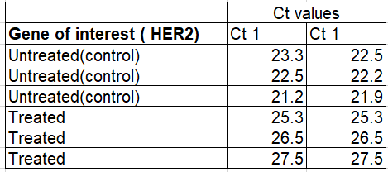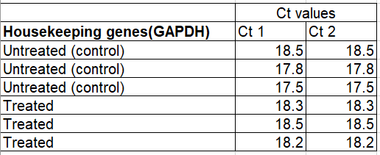

The following data are results of qPCR from cancer cell lines. HER2 stands for human epidermal growth factor. It’s healthy in normal amounts, but too much may be a sign of a certain type of breast cancer. Calculate the 2 Delta Ct values for the following data and plot the values on a graph using graphpad prism.

